

NOVAC TECHNOLOGY SOLUTIONS

User Manual

Document Version No.: 1.00

Revision History
Version No | Reason For Changes | Author | Approver
0.01 | Draft | Ravi Raj
1.00 | Reviewed & Approved the User Manual | Ravi Raj | NIJANTHAN PL

Table of Contents
1. Introduction 4
2. Exclude the DST amount in the refund amount 4

Introduction

The document is prepared to understand the reports generated in ZIVA application for all products. This document is being prepared in reference to:
- Guidelines, circulars, instructions and directions released from time to time by Philippines Insurance council.

Policy Renewal report
System should exclude the DST value from the refund amount in the endorsements where the premium is reduced compared to the original policy or previous endorsements. Following a refund-type endorsement, if user issues a new endorsement that requiring a premium collection from the customer then the system should calculate the DST value for the additional premium and accumulate it with the DST values from previous endorsements / original policy.

Path: Endorsement -> Fire endorsement Financial
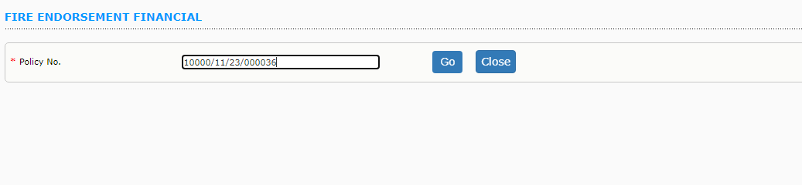

User has to enter the policy Number and click on Go button.

